FONTYS UNIVERSITY OF APPLIED SCIENCES

HBO-ICT: English Stream

Project Core Phase

**User Requirement Specification**

**Modular epidemiological hospital efficiency simulator**

Students:

Amin Masoumzadegan Jahromi

Danas Jusys

Dayana Naydenova

Edgaras Spiridonovas

Ella Seyedkabirian

Project leader: Mateusz Ulas

Tutor:

Andrius Kuprys

Version: 0.2

Curriculum date: 2020 February – June

# Table of Contents

Table of Contents

FIRST ITERATION

USER REQUIREMENT SPECIFICATIONS

Functional requirements

Non-functional requirements

Application wireframes

Simulation visualization

MoSCoW table

Use Cases

REFERENCES

# 

# FIRST ITERATION

## USER REQUIREMENT SPECIFICATIONS

Simulation of modular field hospital experience consists of technical means to control hospital patient ***arrival***, ***treatment*** and ***discharge*** operations. It is an obvious gateway that has to be simulated prior to any subsequent events. Patient arrival is overlooked first.

Latest information suggests that there are several ways of diagnosing whether a patient is infected. One option is clinical diagnosis carried out presumably by a doctor, another option is kit device where a doctor is not required. No assumptions are made on how the patient has arrived to the hospital, assuming self will for all cases.

It can be noted that the approach taken by hospital for patient case calculation raised significant concern, when it was confirmed that Chinese were not accounting for patients that had asymptomatic cases.

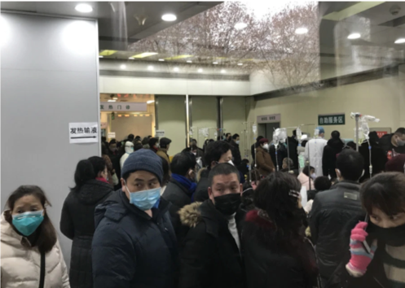

**Fig 3.** Entrance at Wuhan’s Tongji hospital.

Although CAT scans were also confirmed to be counted for case diagnosis, we will omit more sophisticated machinery, until later iterations. This assumes that diagnosis can only happen during a process of medical staff taking a sample from certain person. As a result of mentioned statements, following sequence diagram is presented to summarize patient and hospital arrival interactions, or more particularly two most likely scenarios. It must be noted that in either scenarios, confirmation has to be provided by the on site module laboratory. Note: following sequence is for patient that **don’t have immediate symptoms**, such as fever. Such patients will be admitted firstly and then tested. Where as patients without symptoms will be tested before admission.

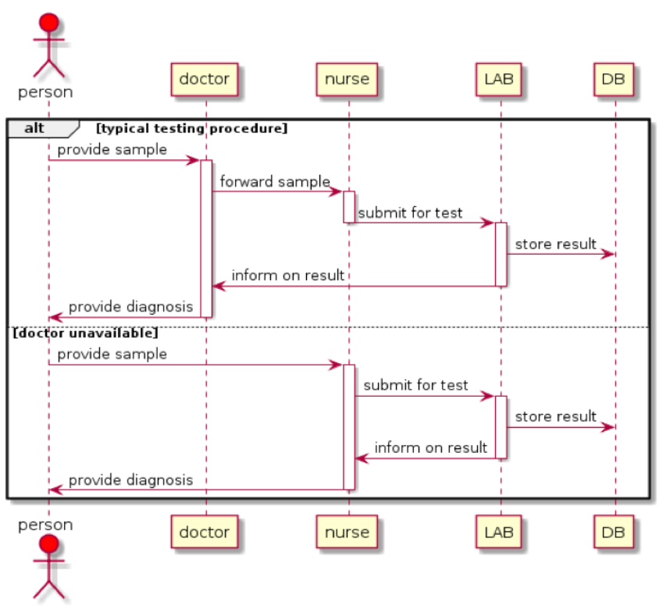

**Fig 4.** Typical patient diagnosis workflow and main exception.

Second goal on iteration one is patient treatment. Based on the output of arrival operation twofold scenario is possible. Obviously patient might be discharged home in case there is no virus detected. However, recently Japan has reported that patients that initially tested negative for the disease, had tested positive after prolonged time period **5**. Therefore, storing information into database is required in order to carry out repetitive testing further into future. Considerations on how patients will be approached for upcoming re-testing will be carried out in upcoming iterations.

Of course, the most important workflow must occur when patient has confirmed virus diagnosis. In such case a patient is immediately transported to one of several modules, where he or she will be cared for until full recovery or death. As is widely known, at the moment the only treatment option is supportive. Since there is no licensed or any other working cure, medical staff must provide assistance when needed. For instance if patient is sweating a lot then hydration and fluid consumption is encouraged, where as if breathing difficulties begin to emerge, assistive respiratory system is deployed.

Aforementioned fact, that care as of this moment can only happen through supportive treatment, implies that staff is obliged to wait out entire fight and recovery process. Upon successful recovery, a patient is discharged and his or hers module is forwarded on to next patient. To be discharged patients are also re-tested for virus in the hospital’s lab.

Having said all this, it should now become evident, that patient queue will depend on the initial specified population parameter. And hospital efficiency will be predicted based on provided funding. Specified amount will be translated by our software into a modular hospital model, where everything is accounted for, including: hospital build and maintenance costs, staff salaries, supply costs, and other factors. A union between these two factors, the infected patient queue size and available treatment options, will determine if available treatment is sufficient for as complete recovery as possible.

### Functional requirements

In order to reiterate postulated statements in a more concise way, functional requirements will be listed here again:

1. User must provide two global parameters: population size and hospital budget.

2. Based on parameter population size, a potential hospital queue is calculated. Assuming that asymptomatic patients do not have to be admitted to hospital, and only symptomatic patients do.

3. Based on parameter hospital budget, a modular field hospital structure, stock and staff count is calculated.

4. Simulation proceeds to position patients expressed as objects, within other quantifiable objects – modules, based on availability.

5. Based on available care capacity, the queue is attempted to be controlled in a gradual manner. Emphasis is placed on not overloading the facility, until full recovery has been achieved and the virus is contained.

6. A summary window is showcases after the simulation is completed, with estimates whether initial budget is suitable for care for the specified population.

This completes self-defined functional requirements for iteration one.

### Non-functional requirements

In order to make user requirement specification complete, a set of non functional requirements

1. To satisfy one of the constraints, previously described action states will be available for database migration through object relational mapper. Our group will use ‘Dapper’ for this purpose, and Heras MySQL for storage.

2. For randomization purposes different parameters can be tailored for various disease spread rates.

3. Simulation application must be reliable, in that it would not crash during usage, and would provide tangible results based on any arrangement of two main parameters, population and budget.

4. Previously shown sequence diagram describes methods and object participants that are programmed in C# programming language, in VS IDE environment.

This completes self-defined non-functional requirements for iteration one.

### 

### Application wireframes

A project must result in working application to manage modular field hospital in epidemiological setting. For iteration one, we anticipate that application should have proposed form, consisting of five main windows, namely general overview, patient registration, room assignment, trend inspection and projection maker. All application tab wireframes are provided below. Most important tab is general overview, as it estimates the efficiency of the hospital based on two main parameters. Other tabs are considered for statistical purposes, to track internal processes.

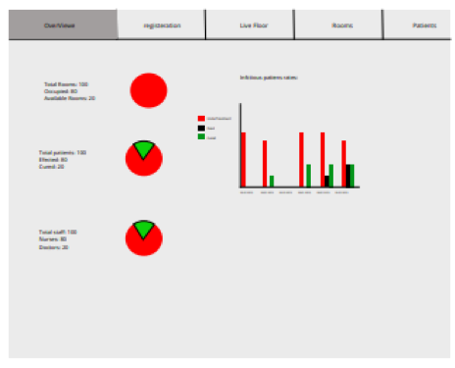

**Fig 6.** General overview tab.

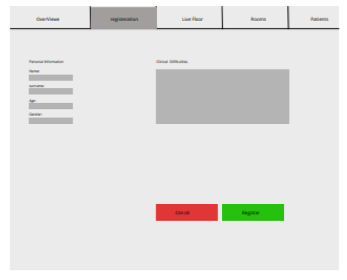

**Fig 7.** Patient registration tab.

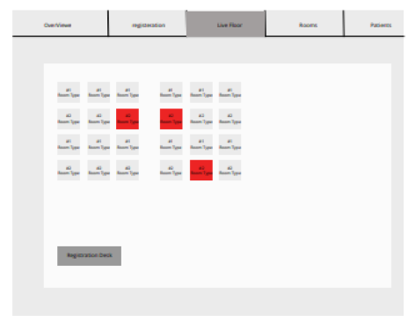

**Fig 8.** Room assignment tab

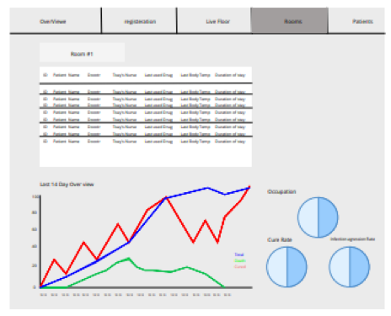

**Fig 9.** Trend inspection tab.

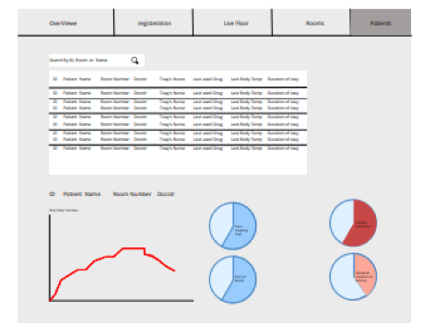

**Fig 10.** Projection tab.

### Simulation visualization

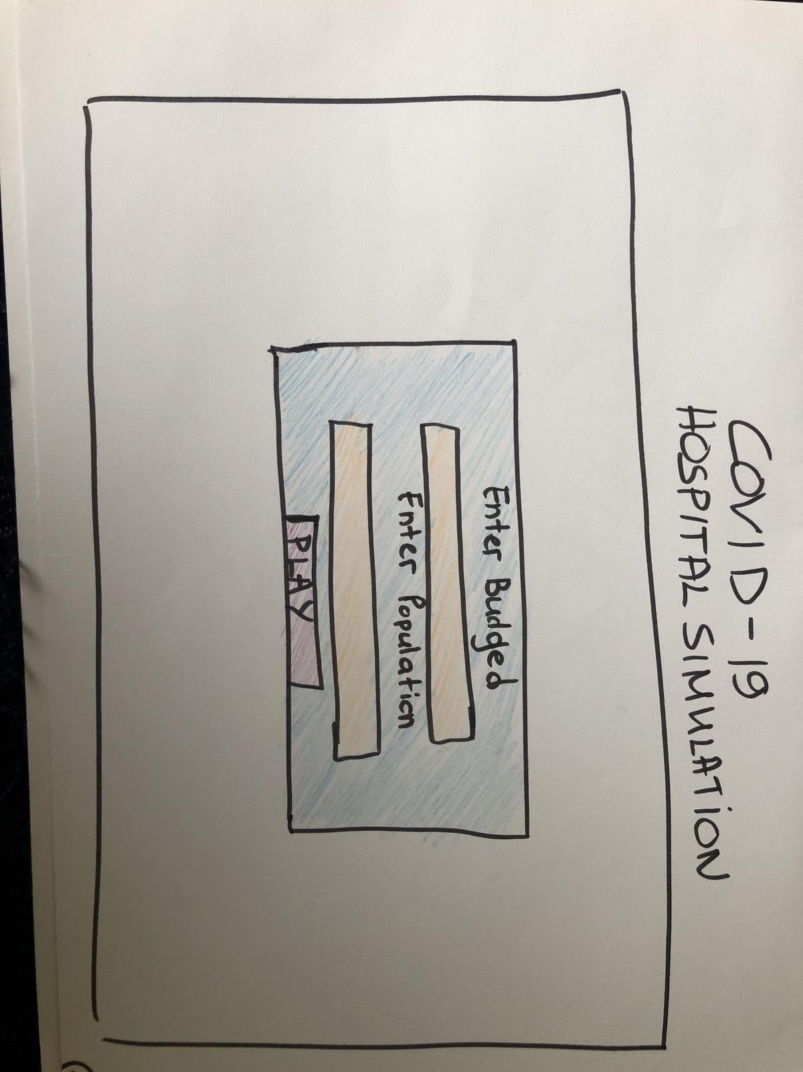

This is the main GUI when the user opens the application.He will be prompted to enter the budget he has and the population number of the town he is in.Based on the budget and the population he enters the application will generate different layout for his/her hospital and different size of queue of patients.





### Application Art

These are the assets that will be used for the visual art for the application 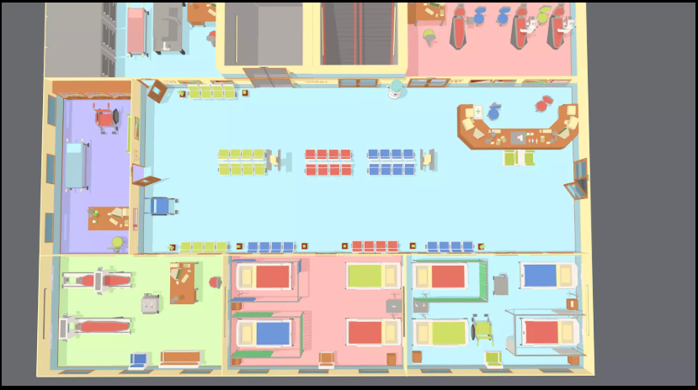

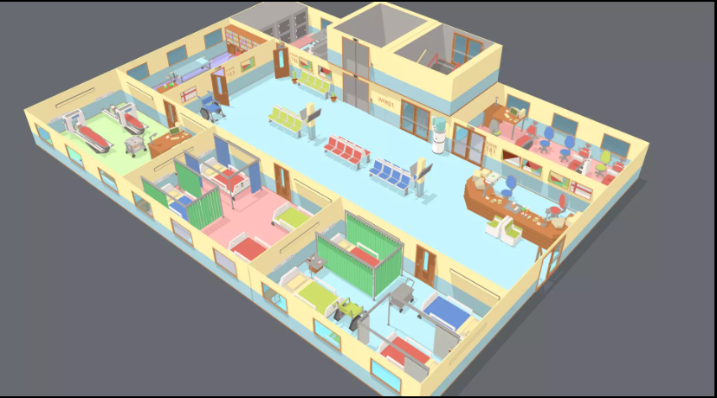

# MoSCoW table

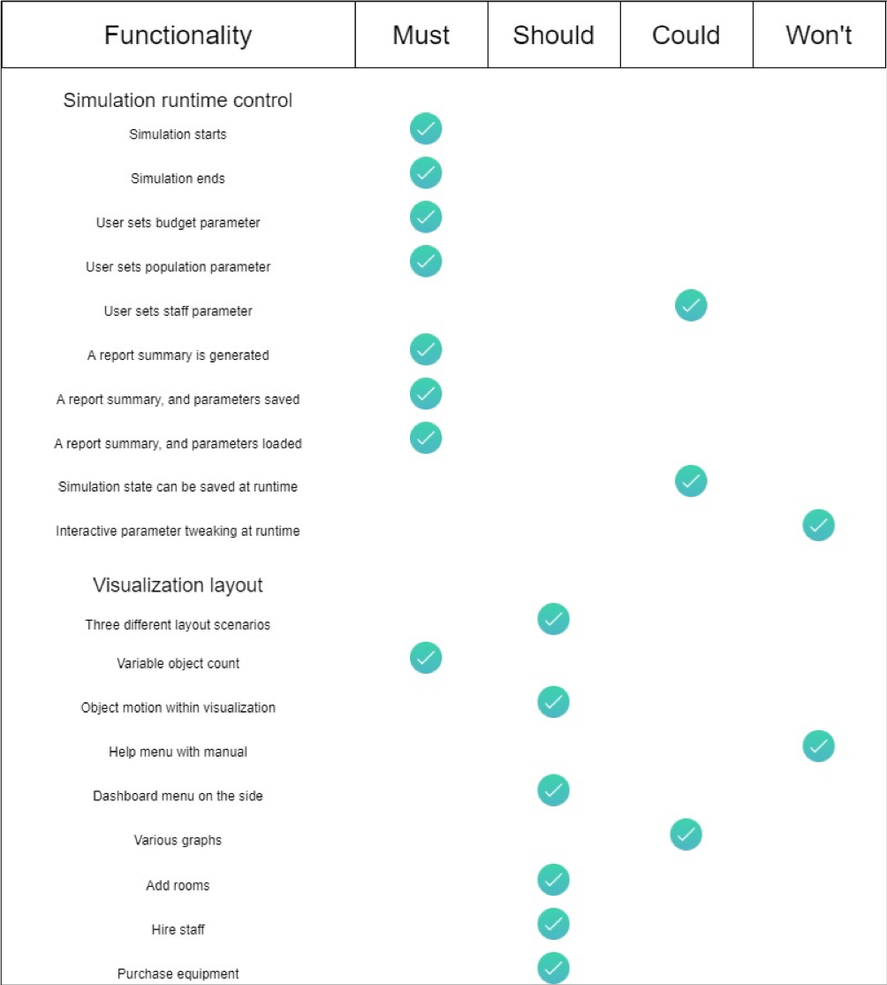

# 

# 

# 

# 

# Use Cases

|  |  |
| --- | --- |
| **Use case** | **Simulation begins** |
| **ID** | 001 |
| **Scope** | Simulation runtime |
| **Summary** | User is able to begin simulation by filling required information, and pressing begin button |
| **Actor** | User of the application |
| **Trigger** | User wants to run the simulation |
| **Normal flow** | 1. System displays main form  2. User inputs parameters in indicated textboxes. Refer to use cases: 003 and 004.  3. User presses begin button.  4. Main form is hidden.  5. Main simulation visualization window is opened.  6. Simulation automatically runs. |
| **Alternate flow /Exceptions** | 3a System displays information whether the input format is valid, it is not. Refer to use case 003 and 004.  2a User cancels the process, use case ends  3a User cancels the process, use case ends |
| **Post conditions** | All subsequent computational events have this user use case as precondition. After the start of simulation, subsequent processes are running automatically. |

|  |  |
| --- | --- |
| **Use case** | **Simulation ends** |
| **ID** | 002 |
| **Scope** | Simulation runtime |
| **Summary** | User is able to observe finished simulation |
| **Actor** | User of the application |
| **Trigger** | User starts simulation |
| **Normal flow** | 1. Simulation automatically runs it’s course, based on input parameters.  2. Simulation arrives at computational binary solution (hospital overwhelmed/all patients cured).  3. Simulation visualization windows is hidden.  4. Graph summary windows is opened.  5. Simulation ends. |
| **Alternate flow /Exceptions** | 1a User cancels the process, use case ends  4a User cancels the process, use case ends |
| **Post conditions** | User is suggested saving option, once simulation is ended |

|  |  |
| --- | --- |
| **Use case** | **Setting budget parameter** |
| **ID** | 003 |
| **Scope** | Simulation parameters |
| **Summary** | User inputs budget for the simulation to be able to run |
| **Actor** | User of the application |
| **Trigger** | User wants to run the simulation, for this he/she needs to input the parameters |
| **Normal flow** | 1. System displays main form  2. User inputs budget parameter in indicated textbox  3. System displays information whether the input format is valid, it is  4. The population parameter is already inputted in valid format, system gives option to run the simulation |
| **Alternate flow /Exceptions** | 3a System displays information whether the input format is valid, it is not, user is required by the system to input data in valid format, use case goes back to step 2  2a User cancels the process, use case ends  4a The population parameter is not inputted or is in invalid format, system gives information about it, user is not able to run the simulation, use case ends and refers to the Use Case with ID 003 |
| **Post conditions** | If user inputted population parameter then he/she is able to run simulation, if not then he/she still needs to input it |

|  |  |
| --- | --- |
| **Use case** | **Setting population parameter** |
| **ID** | 004 |
| **Scope** | Simulation parameters |
| **Summary** | User inputs population for the simulation to be able to run |
| **Actor** | User of the application |
| **Trigger** | User wants to run the simulation, for this he/she needs to input the parameters |
| **Normal flow** | 1. System displays main form  2. User inputs population parameter in indicated textbox  3. System displays information whether the input format is valid, it is  4. The budget parameter is already inputted in valid format, system gives option to run the simulation |
| **Alternate flow /Exceptions** | 3a System displays information whether the input format is valid, it is not, user is required by the system to input data in valid format, use case goes back to step 2  2a User cancels the process, use case ends  4a The budget parameter is not inputted or is in invalid format, system gives information about it, user is not able to run the simulation, use case ends and refers to the Use Case with ID 003 |
| **Post conditions** | If user inputted budget parameter then he/she is able to run simulation, if not then he/she still needs to input it |

|  |  |
| --- | --- |
| **Use case** | **A report summary is generated** |
| **ID** | 005 |
| **Scope** | Post simulation overview |
| **Summary** | System generates a report summary of previously ran simulation |
| **Actor** | System |
| **Trigger** | System ends running simulation flawlessly |
| **Normal flow­** | 1. System informs about finished simulation  2. User acknowledges  3. System generates a summary of the simulation  4. System displays the overview of the report |
| **Alternate flow /Exceptions** | 2a User cancels the process, use case ends |
| **Post conditions** | A report summary is generated, user is able to read it |

|  |  |
| --- | --- |
| **Use case** | **A report summary and parameters saved** |
| **ID** | 006 |
| **Scope** | Post simulation results manipulation |
| **Summary** | User saves a report summary and parameters |
| **Actor** | User of the application |
| **Trigger** | User wants to save the results after system generate and display the report summary |
| **Normal flow** | 1. User presses the button to save the summary and parameters  2. System displays open file dialog  3. User determines name of the file and directory where the file with is going to be saved and confirms choice by button press  4. System saves the file with given name and directory  5. System displays information about successful saving |
| **Alternate flow /Exceptions** | 4a System displays information whether the input format of name and/or the directory is valid, it is not, user is required by the system to input file name and/or directory in valid format, use case goes back to step 3  1a User cancels the process, use case ends  3a User cancels the process, use case goes back to step 1 |
| **Post conditions** | User is able to save and later retrieve the report summary and parameters from the simulation |

# **REFERENCES**

1. Yoshiaki N. et al. - Two Japan Evacuees Get Coronavrus After First Testing Negative. Retrieved on February 2020, at<https://www.bloomberg.com/news/articles/2020-02-11/two-japan-evacuees-get-coronavirus-after-first-testing-negative>